Some basic SQL COMMANDS/STATEMENTS

1. 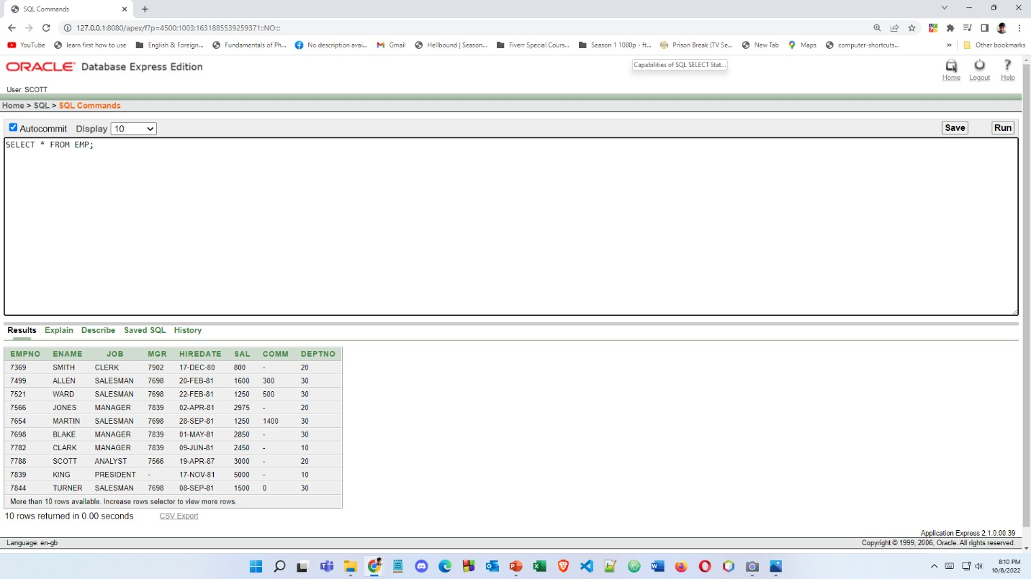HOW TO SELECT ALL COLUMNS
2. SELECTION (SELECTING A SINGLE ROW)

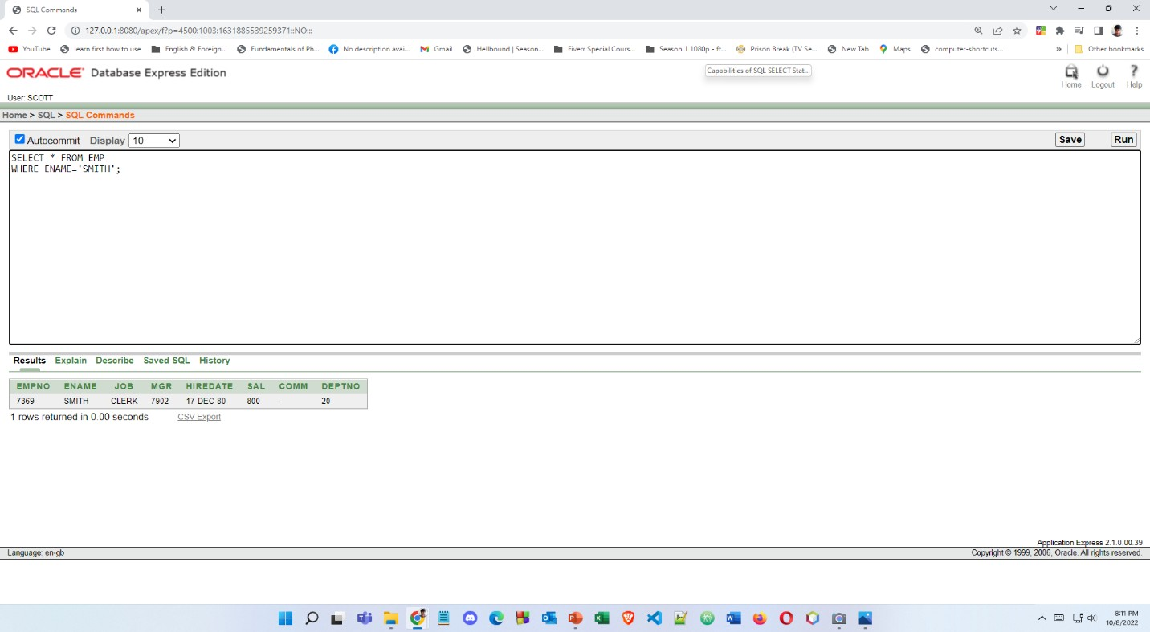

1. PROJECTION (SELECTING ONLY ONE COLUMN)

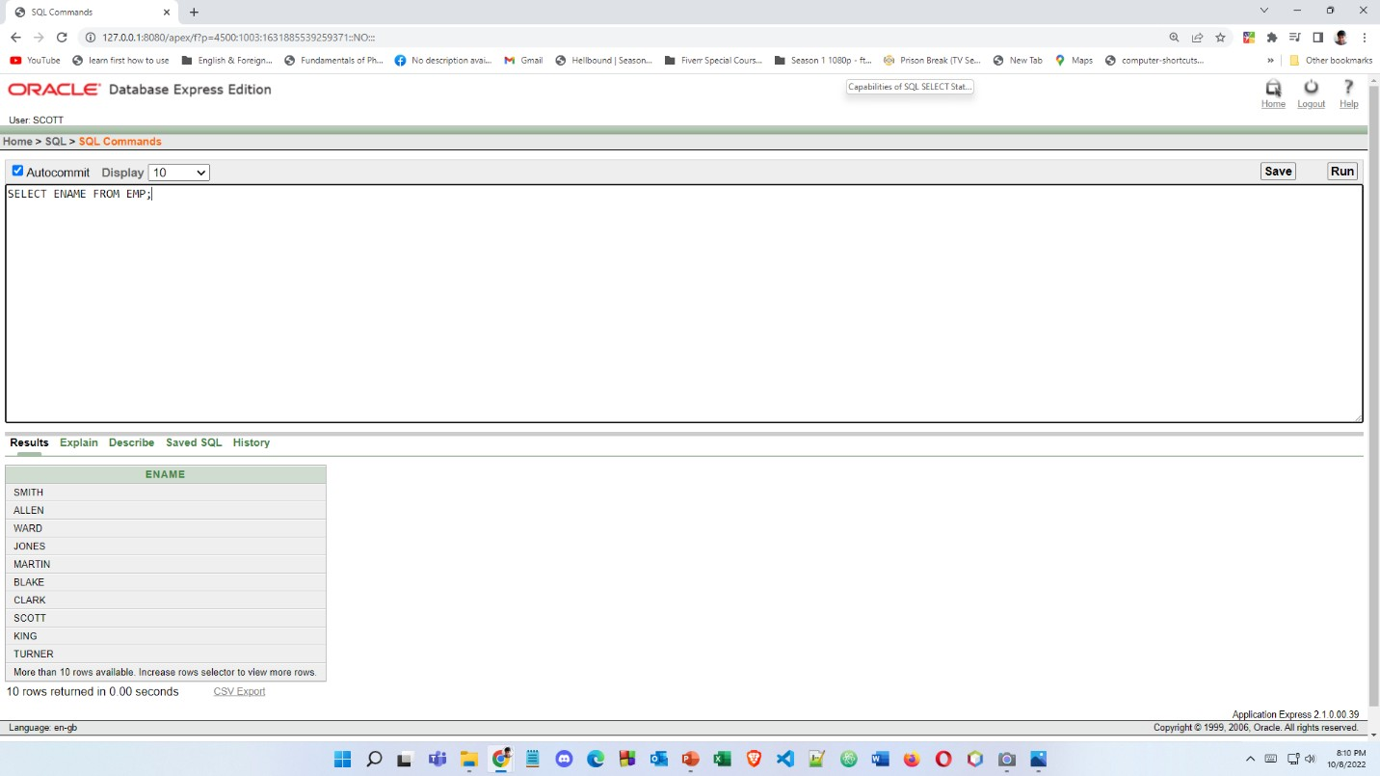

1. 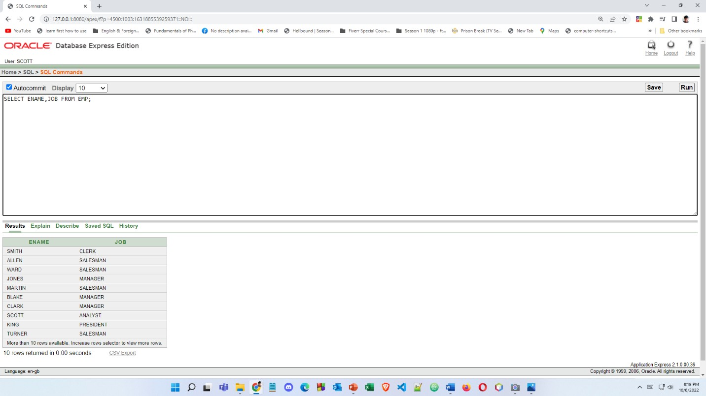HOW TO SELECT SPECIFIC COLUMNS
2. USING ARITHMETIC OPERATORS

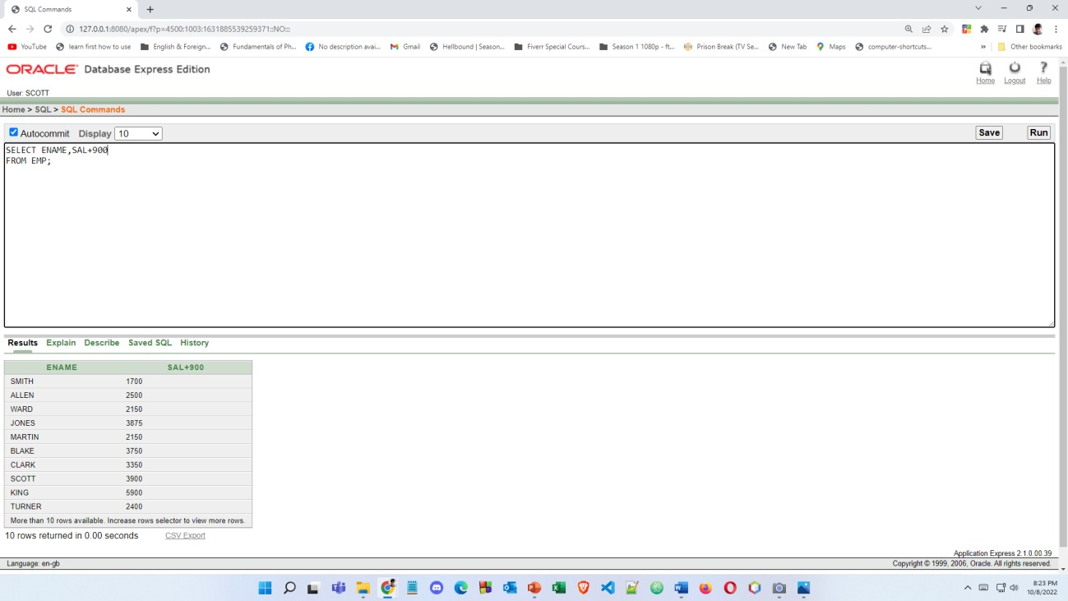

1. USING AIRTHMATIC OPERATORS (+,-,\*./)

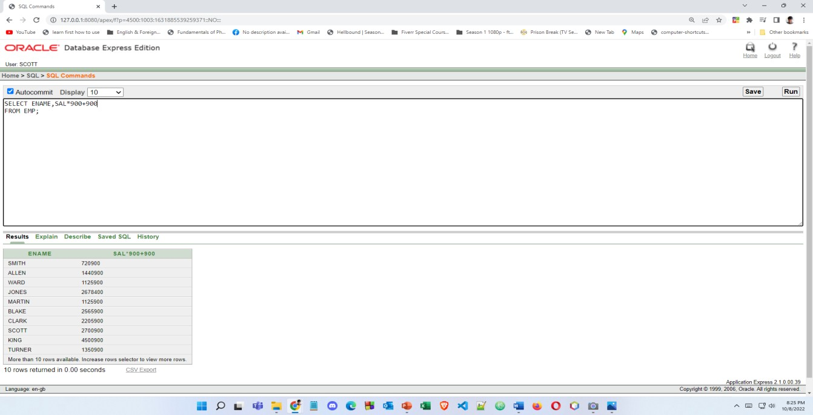

1. USING COLUMN ALIASES (AS STATEMENT)

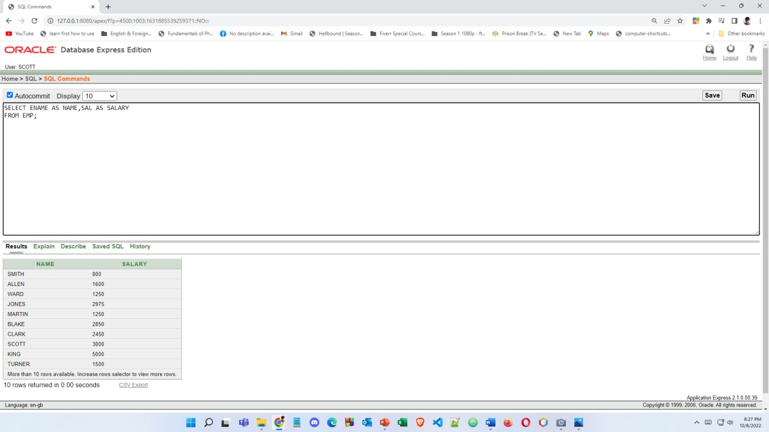

1. CONCETANATION OPERATOR (|| OPERATOR)

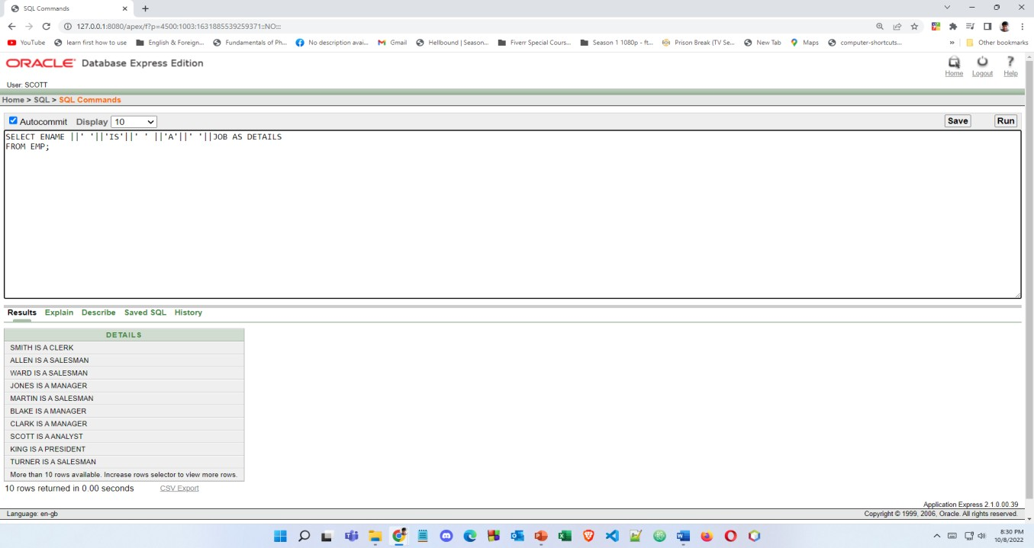

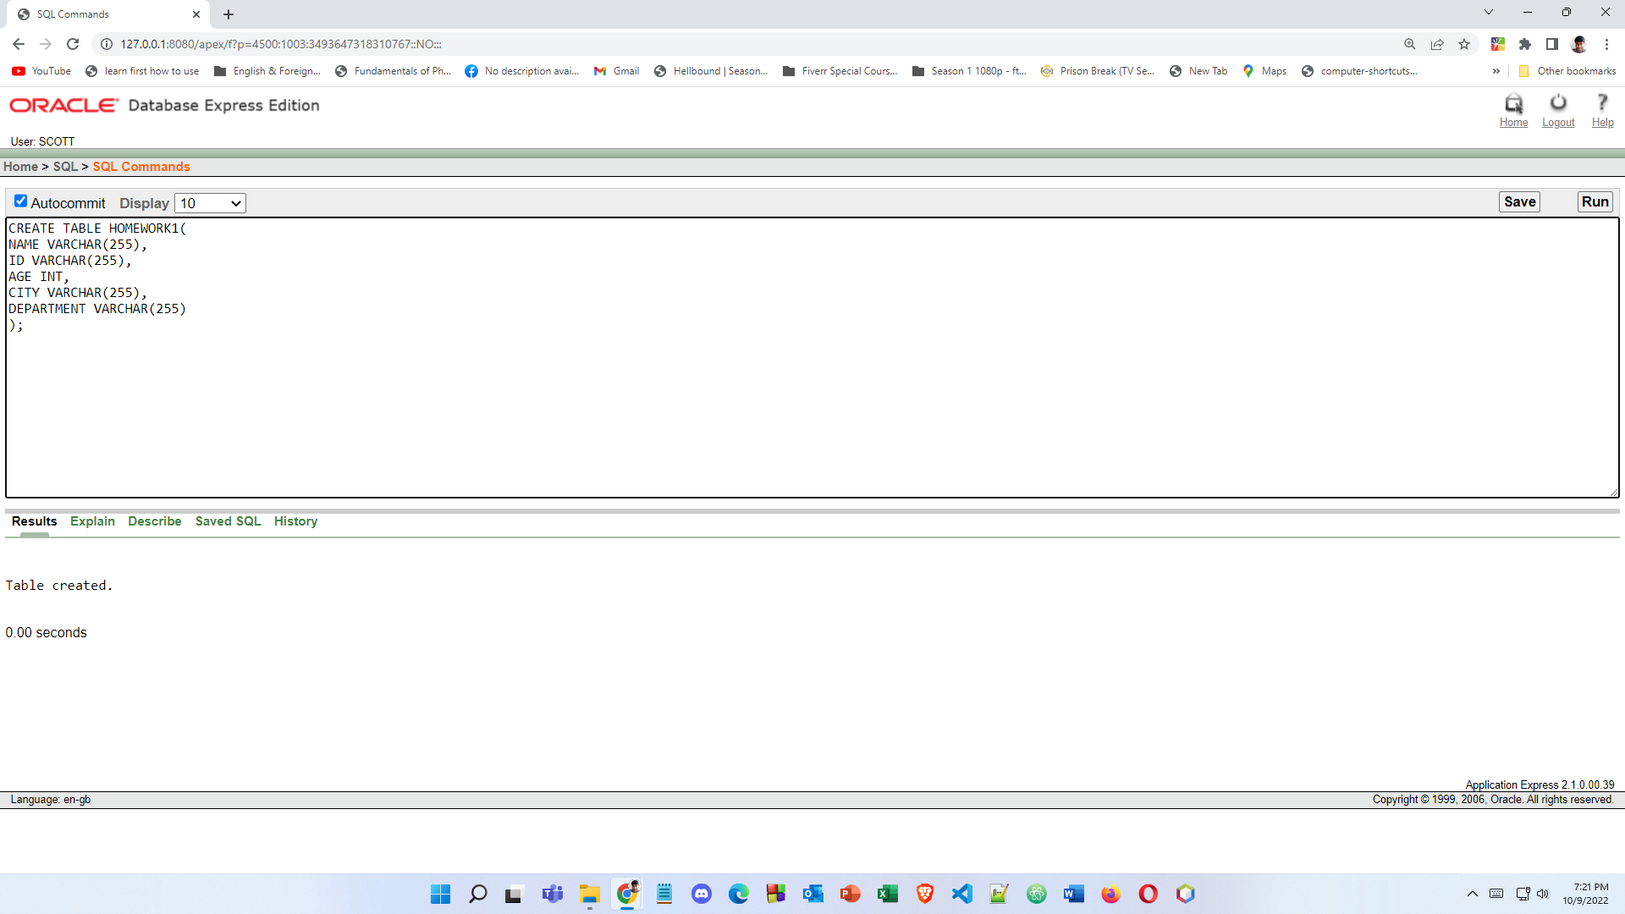9.CREATING A NEW TABLE

10.HOW TO INSERT DATA IN THE TABLE

